C Language Programming: Homework #11
Assigned on 12/14/2023(Thursday), Due on 12/28/2023 (Thursday)

- Write a program that reads data from a file containing a datum called prefix in each line of the file called routing_table. Each prefix has the format of IP/length as following examples: 0.2.64.0/15
0.3.8.0/22
1.3.33.0
1.3.38.0/23
- The first part a.b.c.d is a 32-bit IP address. So, you have to store the IP address into an unsigned variable. For prefixe length, you can use an unsigned character. So, for all the prefixes, you can use an array of struct prefix {unsigned ip; unsigned char len; struct prefix *next;} to store all the prefixes. Assume prefix 0.0.0.0/0 does not exist.
- Do the following,
- write a function input(..) to read all the prefixes from the input file
- print out the total number of prefixes in the input file,
- write a function length_distribution(..) to compute the number of prefixes with prefix length i, for i = 0 to 32,
- write a function segment(int d) to divide the prefixes of length ≥ d into 2^{d} groups such that the prefixes in the same group have the same first d bits. Assume d ≥ 8.
- Now, the prefix of length < d are put in a special group.
- printout the number of prefixes in group i for i = 0 to 2^{d} – 1.
- For each group, you have to use singly linked list to chain the prefixes together.
- Therefore, you have to write a function prefix_insert() to insert a prefix in a one-by-one fashion in the increasing order of the unsigned numbers of the prefixes. A file named inserted_prefixes contains some prefixes that will be inserted after the segments are built from the file routing_table.
- Also, you have to write a function prefix_delete() to delete a prefix. The prefixes to be deleted after inserting all the prefixes from files routing_table and inserted_prefixes are from a file called deleted_prefixes.
- you have to write a function search() by giving an IP address to report if the search is successful or failed. The IP addresses to be searched are contained in a file called trace_file.
- Finally, you have to report average numbers of clock cycles to perform a search, an insertion, or a deletion and draw three figures as follows. How to measure the search/insertion/deletion in cycles is illustruated in clock.c
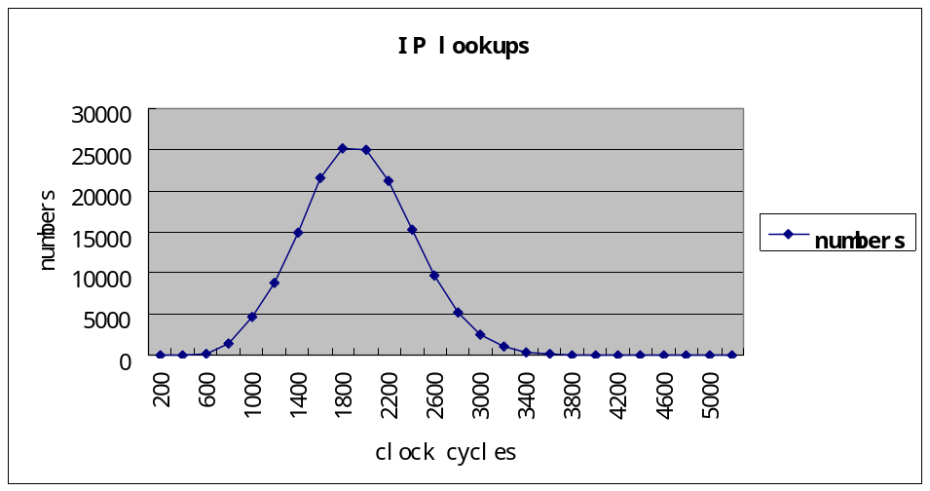
Frequency

